**Lymphedema Rehabilitation (After diagnosis)**

*Complete decongestive therapy using a soft silicone based robot*

**Lymphedema Cure:**

**Complete decongestive therapy (CDT):**

This approach involves combining therapies with lifestyle changes. the therapy program is divided into two phases: Phase I, the Decongestion phase, and Phase II, the Maintenance phase. The goal of Phase I is to decrease the swelling in the limb to normal size, or as close to normal as possible while maintaining healthy skin. Phase II is to preserve the results of all the hard work in Phase I.

CDT Process:

1. Manual lymphatic drainage (MLD): This technique uses a scooping motion with the hand, applying pressure to manually guide trapped lymph fluid out of the affected limb or limbs.
2. compression bandaging: compression garments are used to help the body keep the lymph fluid from building up further, or from reversing the effects of the manual lymph drainage massage. Medical grade compression garments are tightest at the ankle, with a graduated lessening of pressure as they move up the leg.

CTD Period:

1. Complete decongestive therapy for one-hour sessions, 4 to 5 days per week.
2. Bandages with foam are worn about 23 hours per day and often only removed to bathe.

**Solutions Available Now:**

NormaTec Pulse 2.0 is a similar device that I was proposing for the legs. The device should be worn on the legs. It starts inflating Blood Pressure like modules at a different level of the leg. It starts inflating from the toe and gradually inflates the upper part of the leg, removing the Lymph fluid towards the upper side of the body.

<https://www.youtube.com/watch?v=4jMurgZzJSQ>

**Proposed Solution:**

A donut-like device that will be worn over the affected arm or leg that will roll towards the upper side of the limb, putting pressure on the limb and moving lymph fluid away from fingers or toes.

The device will have the following modules:

1. The pressurized donut: This module will be the one that applies pressure to the limb while it is in motion.
2. The climbing mechanism: This module will be a structure that houses a bunch of motors linked circularly. The mechanism will be something similar to a pole climbing robot. This module will drag the pressured donut upwards on the limb.
3. Control and Power Module: This module will be away from the body (can be placed on the ground.) The module will house a small pneumatic pump, battery, controller, and control panel/switches.

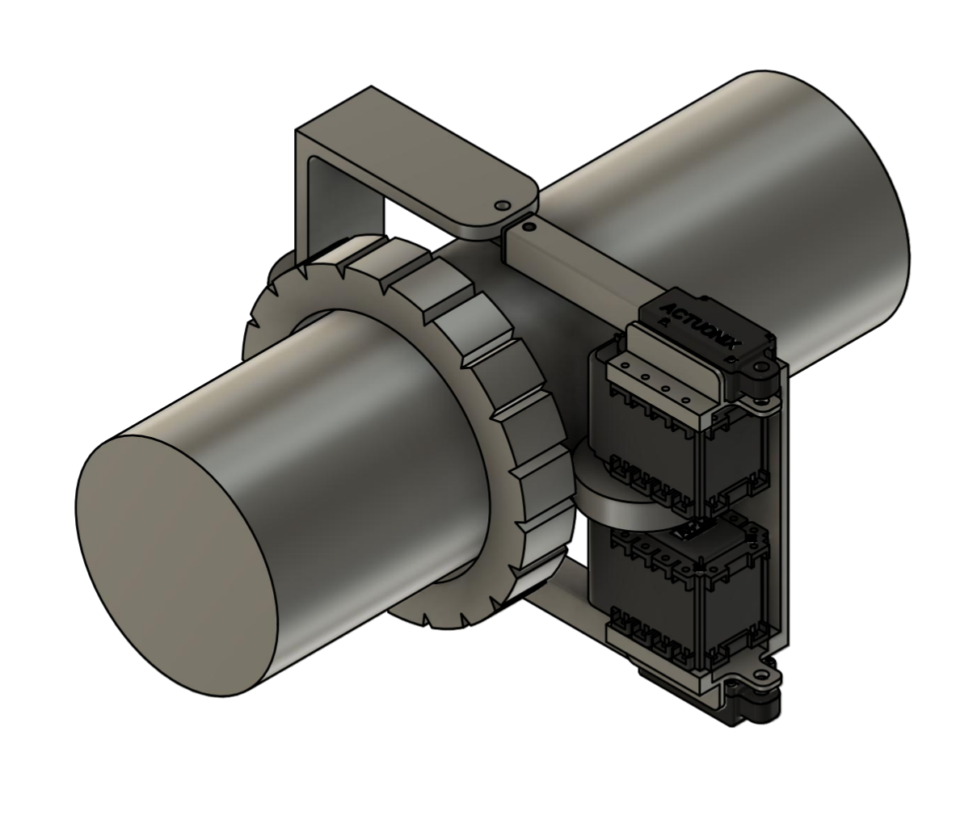

**Design Explanation:**

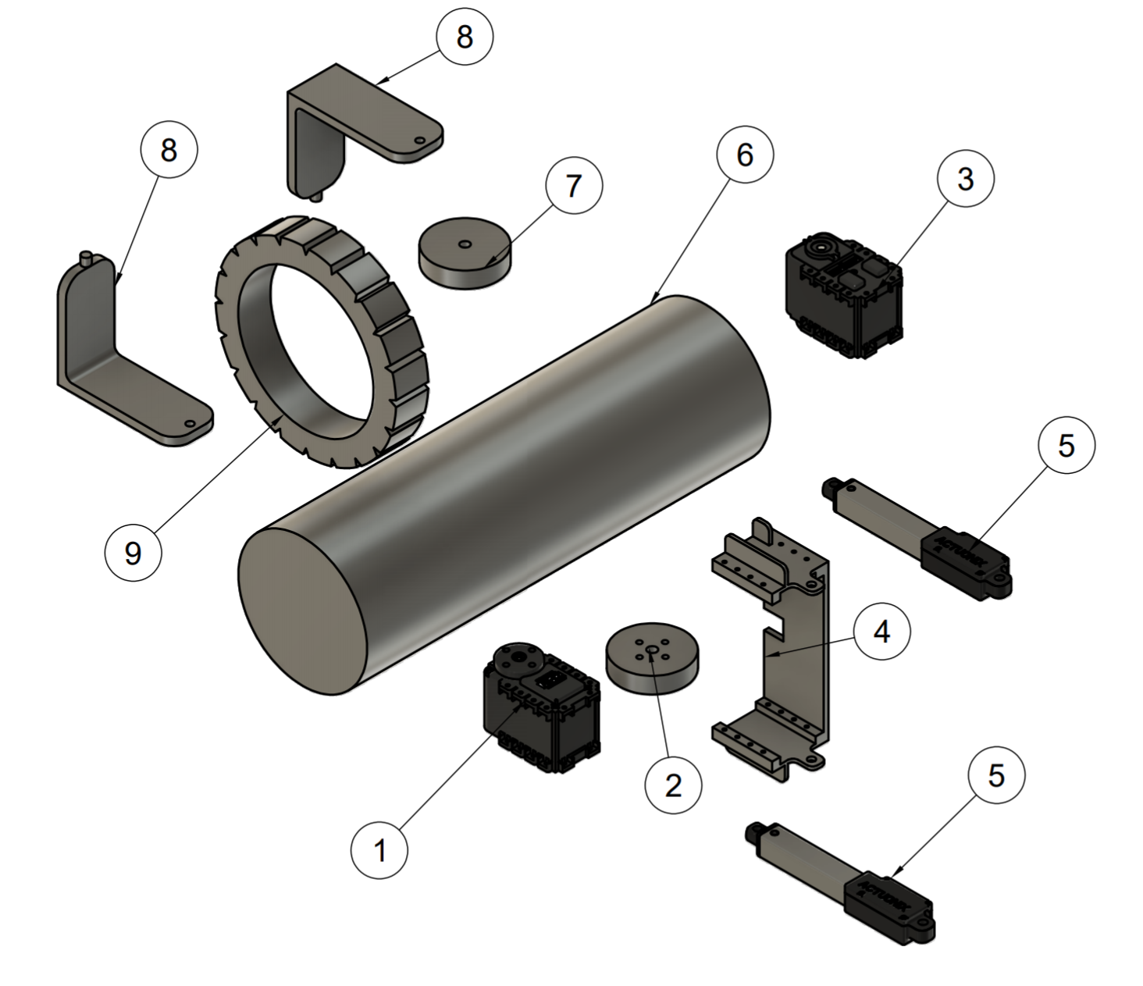

*1-3): Dynamixel AX-12 Servo motors:* Two servo motors will be linked to a wheel that provides the main force for the climbing mechanism.

*2): Wheel:* The wheel that is actuated by the servo motors for limb climbing.

*4): AX12 and Linear actuator housing:* This part will serve as a mounting of the servo motors and two linear actuators

*5): Linear Actuator:* These are the linear actuator which gives the proper mounting normal reaction and friction between the device and the limb. As the device moves upwards, the limb gets fatter and thus a linear actuator can provide dimensional flexibility.

*6): Dummy Limb:* This is a dummy limb for design purposes.

*7): Dummy Wheel:* Non actuated dummy wheel that will provide the support against the actuated wheel.

*8): Dummy Wheel Mounting:* This part provides the mounting for the dummy wheel.

*9): Soft Robotic Silicone Donut*: This module will be the one that applies pressure to the limb while it is in motion.

*Note:* The design is in progress. The number of dummy wheels can be changed, and the design of frames will be changed to increase the contact area for better climbing.

**References:**

1]<https://www.lymphcareusa.com/professional/therapy-solutions/complete-decongestive-therapy.html>

2] <https://www.breastcancer.org/treatment/lymphedema/treatments/cdt>

3] <https://www.lipedema.net/cdt.html>

4] <https://www.mayoclinic.org/diseases-conditions/lymphedema/diagnosis-treatment/drc-20374687>